*Assignment 1(Individual Assignment)*

*Summer 2023*

*Instructor: Faisal Khan*

|  |  |  |
| --- | --- | --- |
| *Name* | *Student ID* | *Group#* |
| *Tajinder Kaur* | *C0861062* | *-* |

1-Use Documentation Comments where needed and use Javadoc to create HTML files for documentation.

2-In your project src folder add this word document with all your group members names and paste the screen shots of your output after each question.

2-Right Click on your Project Folder in Eclipse, Copy Option is available. Create a copy of the Project and upload the zipped folder using Moodle.

Create a web application using Java that does the following:

* Create a login and registration page for your application based on the form below. **[60 marks]**
* Display the information sent from the registration/login page form (see below) to the controller and display it with greeting to the user who has logged in.
* **[40 marks]**

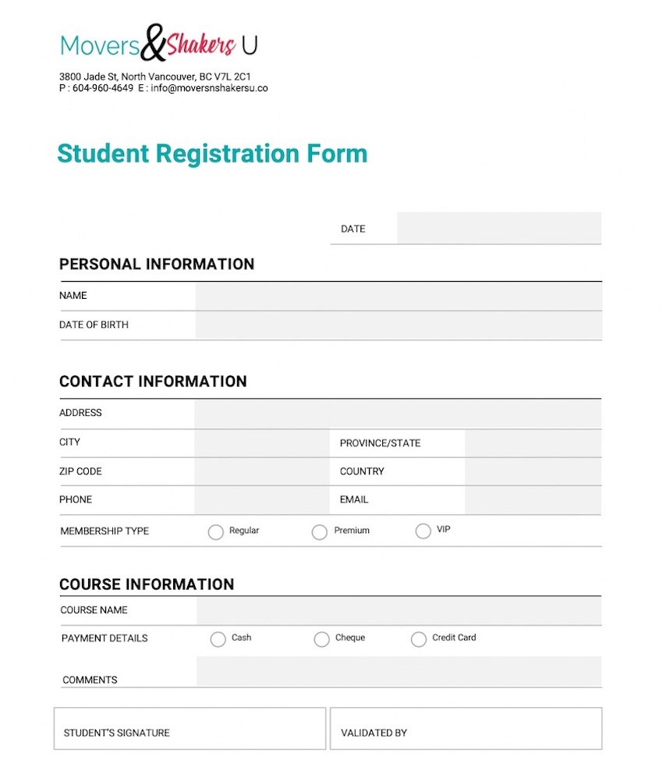

Answer

The directory structure of the whole application is:

1. To create the above web application first create a webpage.
2. The Student_portal.html web page helps the user to navigate from the Student_portal.html page to RegistrationForm.html and Login.html.

Coding of Student_portal.html webpage

<!DOCTYPE html>

<html>

<head>

<meta charset=*"ISO-8859-1"*>

<title>Student Portal</title>

<link href=*"https://cdn.jsdelivr.net/npm/bootstrap@5.2.3/dist/css/bootstrap.min.css"* rel=*"stylesheet"*>

<script src=*"https://cdn.jsdelivr.net/npm/bootstrap@5.2.3/dist/js/bootstrap.bundle.min.js"*></script>

</head>

<body>

<div class=*"container"*>

<form>

<h1 class=*"p-5 my-5 bg-dark text-white"*>Student Portal</h1>

<p>Welcome in the student Portal</p>

<p>New students can do registration by click on the registration link. </p>

<a href=*"RegistrationForm.html"*>Register here...... </a>

<p>The students who already register can login in into their portal by click on the Log in button </p>

<a href=*"Login.html"*> Login here.....</a>

</form>

</div>

</body>

</html>

1. After the above page create RegistrationForm.html to collect the information of the user who wants to register for student portal services.

Coding of RegistrationForm.html webpage

<!DOCTYPE html>

<html>

<head>

<meta charset=*"ISO-8859-1"*>

<title>Insert title here</title>

<link href=*"https://cdn.jsdelivr.net/npm/bootstrap@5.2.3/dist/css/bootstrap.min.css"* rel=*"stylesheet"*>

<script src=*"https://cdn.jsdelivr.net/npm/bootstrap@5.2.3/dist/js/bootstrap.bundle.min.js"*></script>

</head>

<body>

<div class=*"container"*>

<form action=*"myservelet"* method=*"post"*>

<h1 class=*"p-5 my-5 bg-dark text-white"*>Student Registration Form</h1>

<h2 class=*"mt-3 mb-3 border-bottom border-dark border-2"*>Personal Information</h2>

<div class=*"input-group mb-3"*>

<span class=*"input-group-text"*>ID</span>

<input type=*"text"* class=*"form-control"* id=*"stu_id"* name=*"stu_id"*>

</div>

<div class=*"input-group mb-3"*>

<span class=*"input-group-text"*>Name</span>

<input type=*"text"* class=*"form-control"* id=*"name"* name=*"name"*>

</div>

<div class=*"input-group mb-3"*>

<span class=*"input-group-text"*>Date of birth</span>

<input type=*"text"* class=*"form-control"* id=*"dob"* name=*"dob"*>

</div>

<h2 class=*"mt-3 mb-3 border-bottom border-dark border-2"*>Contact Information</h2>

<div class=*"input-group mb-3"*>

<span class=*"input-group-text"*>Address</span>

<input type=*"text"* class=*"form-control"* id=*"address"* name=*"address"*>

</div>

<div class=*"input-group mb-3"*>

<span class=*"input-group-text"*>City</span>

<input type=*"text"* class=*"form-control"* id=*"city"* name=*"city"*>

</div>

<div class=*"input-group mb-3"*>

<span class=*"input-group-text"*>Province/State</span>

<input type=*"text"* class=*"form-control"* id=*"province"* name=*"province"*>

</div>

<div class=*"input-group mb-3"*>

<span class=*"input-group-text"*>ZIP Code</span>

<input type=*"text"* class=*"form-control"* id=*"zip"* name=*"zip"*>

</div>

<div class=*"input-group mb-3"*>

<span class=*"input-group-text"*>Country</span>

<input type=*"text"* class=*"form-control"* id=*"country"* name=*"country"*>

</div>

<div class=*"input-group mb-3"*>

<span class=*"input-group-text"*>Phone</span>

<input type=*"text"* class=*"form-control"* id=*"phone"* name=*"phone"*>

</div>

<div class=*"input-group mb-3"*>

<span class=*"input-group-text"*>Email</span>

<input type=*"email"* class=*"form-control"* id=*"email"* name=*"email"*>

</div>

<div class=*"input-group mb-3"*>

<span class=*"input-group-text"*>Password</span>

<input type=*"password"* class=*"form-control"* id=*"password"* name=*"password"*>

</div>

<h2 class=*"mt-3 mb-3 border-bottom border-dark border-2"*>Course Information</h2>

<div class=*"input-group mb-3"*>

<span class=*"input-group-text"*>Course Name</span>

<input type=*"text"* class=*"form-control"* id=*"course"* name=*"course"*>

</div>

<div class=*"input-group mb-3"*>

<span class=*"input-group-text"*>Comment</span>

<input type=*"text"* class=*"form-control"* id=*"comment"* name=*"comment"*>

</div>

<input type=*"submit"* value=*"submit"*/>

</form>

</div>

</body>

</html>

1. After the above webpage create the Login.html page which allows only registered users to login into the portal.

Coding of Login.html webpage

<!DOCTYPE html>

<html>

<head>

<meta charset=*"ISO-8859-1"*>

<title>Student Login Portal</title>

<link href=*"https://cdn.jsdelivr.net/npm/bootstrap@5.2.3/dist/css/bootstrap.min.css"* rel=*"stylesheet"*>

<script src=*"https://cdn.jsdelivr.net/npm/bootstrap@5.2.3/dist/js/bootstrap.bundle.min.js"*></script>

</head>

<body>

<div class=*"container"*>

<form class=*"was-validated"* action=*"LoginServelet"* method=*"post"*>

<h1 class=*"p-5 my-5 bg-dark text-white text-center"*>Student Login Form</h1>

<h2 class=*"mt-3 mb-5 border-bottom border-dark border-2 text-center"*>Login</h2>

<div class=*"form-floating mb-3 mt-3"*>

<input type=*"email"* class=*"form-control"* id=*"email"* placeholder=*"Enter email"* name=*"email"* required>

<label for=*"email"*>Email</label>

<div class=*"valid-feedback"*>Valid.</div>

<div class=*"invalid-feedback"*>Please Enter The Valid Email.</div>

</div>

<div class=*"form-floating mt-3 mb-3"*>

<input type=*"password"* class=*"form-control"* id=*"pwd"* placeholder=*"Enter password"* name=*"password"* required>

<label for=*"pwd"*>Password</label>

<div class=*"valid-feedback"*>Valid.</div>

<div class=*"invalid-feedback"*>Please Enter The Valid Password.</div>

</div>

<input type=*"submit"* value=*"submit"*/>

</form>

</div>

</body>

</html>

1. Now firstly create a database in the XAMMP server. The name of our database is student_registration.db with the table name registration_table.

The screenshot of the database is:

1. Now create a conn.cestar.modal package inside it create a Student class. It act as a modal class.

The coding of Student class is

**package** conn.cestar.modal;

**public** **class** Student {

**private** **int** stu_id;

**private** String name;

**private** String dob;

**private** String address;

**private** String city;

**private** String province;

**private** String zip;

**private** String country;

**private** String phone;

**private** String email;

**private** String password;

**private** String course;

**private** String comment;

**public** **int** getStu_id() {

**return** stu_id;

}

**public** **void** setStu_id(**int** stu_id) {

**this**.stu_id = stu_id;

}

**public** String getName() {

**return** name;

}

**public** **void** setName(String name) {

**this**.name = name;

}

**public** String getDob() {

**return** dob;

}

**public** **void** setDob(String dob) {

**this**.dob = dob;

}

**public** String getAddress() {

**return** address;

}

**public** **void** setAddress(String address) {

**this**.address = address;

}

**public** String getCity() {

**return** city;

}

**public** **void** setCity(String city) {

**this**.city = city;

}

**public** String getProvince() {

**return** province;

}

**public** **void** setProvince(String province) {

**this**.province = province;

}

**public** String getZip() {

**return** zip;

}

**public** **void** setZip(String zip) {

**this**.zip = zip;

}

**public** String getCountry() {

**return** country;

}

**public** **void** setCountry(String country) {

**this**.country = country;

}

**public** String getPhone() {

**return** phone;

}

**public** **void** setPhone(String phone) {

**this**.phone = phone;

}

**public** String getEmail() {

**return** email;

}

**public** **void** setEmail(String email) {

**this**.email = email;

}

**public** String getPassword() {

**return** password;

}

**public** **void** setPassword(String password) {

**this**.password = password;

}

**public** String getCourse() {

**return** course;

}

**public** **void** setCourse(String course) {

**this**.course = course;

}

**public** String getComment() {

**return** comment;

}

**public** **void** setComment(String comment) {

**this**.comment = comment;

}

@Override

**public** String toString() {

**return** "Student [stu_id=" + stu_id + ", name=" + name + ", dob=" + dob + ", address=" + address + ", city="

+ city + ", province=" + province + ", zip=" + zip + ", country=" + country + ", phone=" + phone

+ ", email=" + email + ", password=" + password + ", course=" + course + ", comment=" + comment + "]";

}

**public** Student(**int** stu_id, String name, String dob, String address, String city, String province, String zip,

String country, String phone, String email, String password, String course, String comment) {

**super**();

**this**.stu_id = stu_id;

**this**.name = name;

**this**.dob = dob;

**this**.address = address;

**this**.city = city;

**this**.province = province;

**this**.zip = zip;

**this**.country = country;

**this**.phone = phone;

**this**.email = email;

**this**.password = password;

**this**.course = course;

**this**.comment = comment;

}

**public** Student() {

**super**();

// **TODO** Auto-generated constructor stub

}

}

1. Now create another package with the name conn.cestar.tester. under this package create a Student_Dao.java class. This class has a method to create a connection, insert the data in the database and function to fetch data from the database.

The code of Student_Dao.java class is

**package** conn.cestar.tester;

**import** java.sql.Connection;

**import** java.sql.DriverManager;

**import** java.sql.PreparedStatement;

**import** java.sql.ResultSet;

**import** java.sql.SQLException;

**import** conn.cestar.modal.Student;

**public** **class** Student_Dao {

**public** **static** Connection *con* ;

// create a connection with the database

**public** **static** Connection setUpConnection() {

String user="root";

String pwd="";

String url="jdbc:mysql://localhost:3306/Student_registration";

**try** {

Class.*forName*("com.mysql.jdbc.Driver");

*con* = DriverManager.*getConnection*(url, user, pwd);

System.***out***.println("connection successful!!!!!!!!!!");

} **catch** (ClassNotFoundException e) {

// **TODO** Auto-generated catch block

e.printStackTrace();

} **catch** (SQLException e) {

// **TODO** Auto-generated catch block

e.printStackTrace();

}

**return** *con*;

}

// create a insertRec method to insert the data in the database

**public** **int** insertRec(Student stu_servlet) {

**int** status=0;

Connection con = *setUpConnection*();

String sql = "INSERT into registration_table(stu_id,name,dob,address,city,province,zip,country,phone,email,password,course,comment) values(?,?,?,?,?,?,?,?,?,?,?,?,?)";

**try** {

PreparedStatement ps = con.prepareStatement(sql);

ps.setInt(1, stu_servlet.getStu_id());

ps.setString(2,stu_servlet.getName());

ps.setString(3, stu_servlet.getDob());

ps.setString(4, stu_servlet.getAddress());

ps.setString(5, stu_servlet.getCity());

ps.setString(6, stu_servlet.getProvince());

ps.setString(7, stu_servlet.getZip());

ps.setString(8, stu_servlet.getCountry());

ps.setString(9, stu_servlet.getPhone());

ps.setString(10, stu_servlet.getEmail());

ps.setString(11, stu_servlet.getPassword());

ps.setString(12, stu_servlet.getCourse());

ps.setString(13, stu_servlet.getComment());

status = ps.executeUpdate();

**if**(status>0) {

System.***out***.println("Record is inserted");

}

**else** {

System.***out***.println("Sorry there is some problem");

}

} **catch** (SQLException e) {

// **TODO** Auto-generated catch block

e.printStackTrace();

}

**return** status;

}

// create a getData method to fetch the data from the database according to email and password entered by the user

**public** Student getData(String stu_email, String stu_pass ) {

Student stu = **null**;

Connection con = *setUpConnection*();

String sql = "Select * from registration_table where email=? AND Password=?";

**try** {

PreparedStatement pstmt = con.prepareStatement(sql);

pstmt.setString(1, stu_email);

pstmt.setString(2, stu_pass);

ResultSet rs = pstmt.executeQuery();

**while**(rs.next()) {

stu = **new** Student(rs.getInt("stu_id"),rs.getString("name"),rs.getString("dob"),rs.getString("address"),

rs.getString("city"),rs.getString("province"),rs.getString("zip"),rs.getString("country"),rs.getString("phone"),

rs.getString("email"),rs.getString("password"),rs.getString("course"),rs.getString("comment"));

}

**catch** (SQLException e) {

// **TODO** Auto-generated catch block

e.printStackTrace();

}

**return** stu;

}

}

1. Create another package conn.cestar.servelet. it includes two servelet classes. One for LoginServleet.java and the other for myservlet.java. when the user login the page is navigated to the Loginservlet.java and when the user register the page is navigated to the myservelet.java

Code for LoginServelet.java

Code for myservelet.java

1. Now run the code and start testing from the student_portal.html page

1. Click on register link here to make registration

1. Fill out the registration form and click on the submit button you navigate to myservelet.java if registration is successful.

1. Now click here button to come back to Student_portal services page and login into the student_portal

1. Now click on the login link

Fill the login form with appropriate information

If the user try to login who is not register then the following message display on the user screen.

